**“VERIFICTION OF THEVENIN THEOREM AND NORTON THEOREM”**

# Objectives:

* To understand the Thevenin theorem.
* To understand Norton’s theorem.
* To prove these theorems using the pspice.

**Thevenin’s Theorem**

Theorem states that any combination of batteries and resistances with two terminals can be replaced by a single voltage source (e) and a single series resistor (r). The value of (e) is the open circuit voltage at the terminals, and the value of (r) is (e) divided by the current with the terminals short circuited.

**pspice:-**

The circuit file contains different functions which makes the work of an engineer more easy. One can put any sort of symbol using this software and can make different types of circuit diagrams

# Proving the Thevenin Theorem using the pspice:

**OBSERVATIONS:**

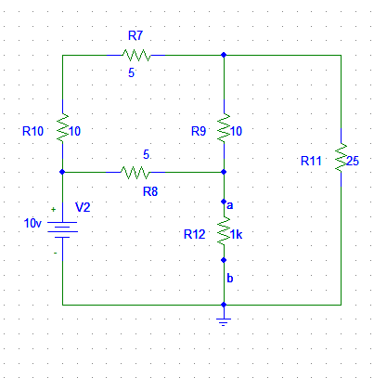

## Circuit Diagram

* First we will find the Vth using pspice.

The procedure for this is to make a and b open.

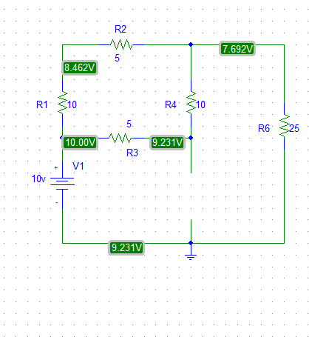

# Circuit Diagram

The value of Vth is 9.231.

* Next we have to find the Isc

For this we will make the a and b short circuit.

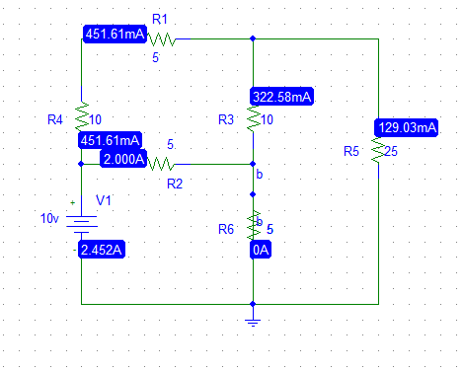

# Circuit Diagram

The value of Isc is 2.45.

* Now we will find the Rth

Rth=Vth/Isc

Rth=3.76

# The Thevenin equivalent circuit

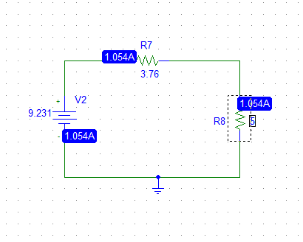

# Norton’s Theorem

Any collection of batteries and resistances with two terminals is electrically equivalent to an ideal current source i in parallel with a single resistor r. The value of r is the same as that in the Thevenin equivalent and the current i can be found by dividing the open circuit voltage by r.

(Source Transformation)

# Circuit Diagram

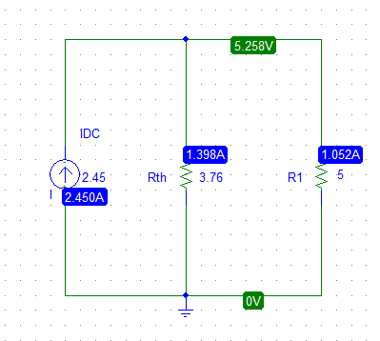

**conclusion:**

 It is possible to simplify any linear circuit, Throughout this experiment, the resistances are simplified into only one that is R TH .